
FOUNDATION LEVEL • CHAPTER 1
George Washington
America’s First President | ESL United Historical Series
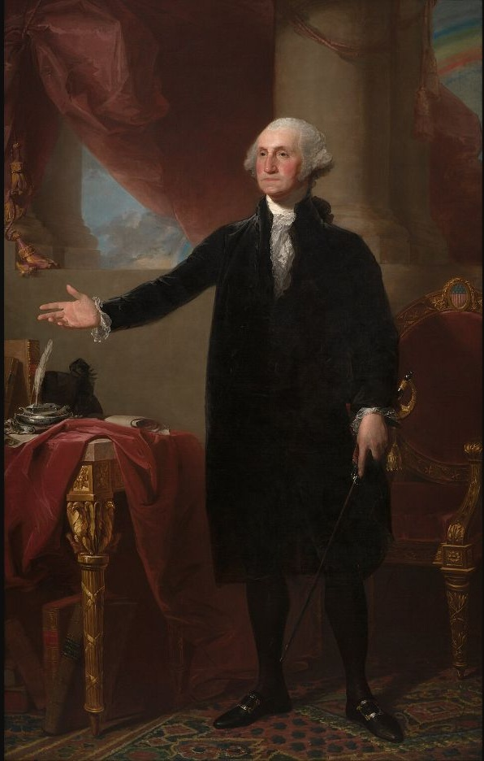
George Washington (Lansdowne Portrait), Gilbert Stuart, 1796. Public domain.
YEARS | VICE PRESIDENT | PRESIDENT’S WIFE | PARTY
1789–1797 | John Adams | Martha Washington | No formal party

After this lesson, I can…
✓ identify George Washington and people who served with him.
✓ describe important events in his life using the simple past.
✓ answer a George Washington question from the USCIS civics test.

Read: A New Nation’s First Leader
George Washington was born in Virginia on February 22, 1732. As a young man, he worked as a surveyor. Later, he became a soldier. During the American Revolution, Washington served as Commander-in-Chief of the Continental Army. In 1787, he presided over the Constitutional Convention.
In 1789, the Electoral College unanimously chose Washington as the first President of the United States. John Adams served as vice president. Martha Washington managed the presidential household and hosted public events. Washington helped organize the new federal government. He served two terms and left office in 1797, supporting a peaceful transfer of power.
HISTORICAL CONTEXT Washington enslaved people at Mount Vernon. His leadership in the fight for independence existed alongside slavery. Studying both facts gives us a fuller view of early U.S. history.
USCIS CIVICS CONNECTION George Washington is famous for many things. Name one. Acceptable answers include: Father of Our Country; first U.S. president; or general of the Continental Army.
SCAN THIS PAGE
READ + LISTEN | CIVICS PRACTICE
  20+ languages  ESLUnited.org |   20+ languages  ESLUnited.org
STUDENT PRACTICE
Vocabulary & Activities
Name: ____________________________________ Date: ____________________
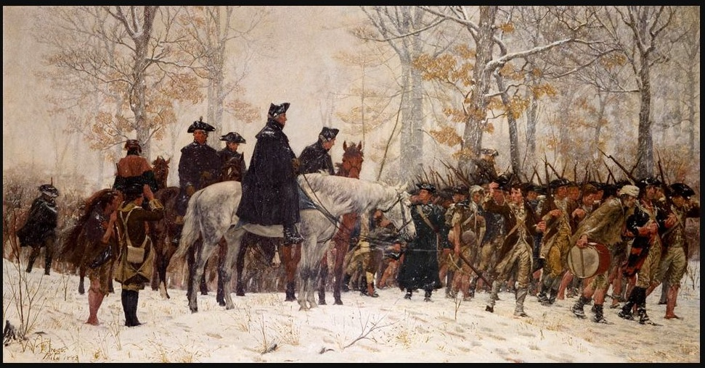
March to Valley Forge, William B. T. Trego, 1883. Public domain.

1. Key Vocabulary
ENGLISH | PRONUNCIATION | SPANISH
president | PREZ-i-dent | presidente
surveyor | ser-VAY-er | agrimensor/a
commander | kuh-MAN-der | comandante
army | AR-mee | ejército
convention | kun-VEN-shun | convención
term | term | mandato

2. Match the Word
Write A, B, or C. 1. surveyor ____ 2. army ____ 3. term ____
A. organized soldiers B. a set length of time in office C. a person who measures land

3. Reading Check & Order
1. Washington was born in ☐ Virginia ☐ New York. 2. His vice president was ☐ John Adams ☐ James Madison.
3. He led the ☐ Continental Army ☐ U.S. Navy. 4. He served ☐ two terms ☐ three terms.
Order 1–5: ____ surveyor ____ army leader ____ Convention ____ president ____ left office

4. Speak & Write
Partner question: Why is George Washington important?
George Washington is important because he ________________________________________________.
DIGITAL PRACTICE FOR EACH SECTION
1 WORDS | 2 MATCH | 3 CHECK | 4 SPEAK
  20+ languages  ESLUnited.org |   20+ languages  ESLUnited.org |   20+ languages  ESLUnited.org |   20+ languages  ESLUnited.org

